Part I: Research Question

- Research Question

How well can we predict whether a customer will sign up to stream movies using variable proximity with a k-nearest neighbor algorithm?

- Goals of Analysis

The goal is to build an optimized KKN model that can accurately predict whether someone will sign up for streaming movies or not, any patterns found will be reported, but this will not be the main focus of the project.

Part II: Method Justification
- Classification Method

KNN is used to make predictions using a majority vote based on the classification of predictor variables in close proximity.

- One Assumption of KNN

The main assumption of KNN is that data points in close proximity are similar to one another. KNN is a lazy algorithm and simply uses a voting method on k nearest neighbors found using a distance metric to make a classification based on said neighboring predictor values.

- Libraries used in Python

Library | Module | Use | Description
Sklearn | preprocessing | Scaling data | Used Standard Scaler on all X data
 | Model_selection | Splitting data into train and test sets, cross validation for hyperparameter tuning | GridSearchCV for hyperparameter tuning and train_test_split for the final KNN algorithm
 | neighbors | Used KNN algorithm from sklearn | Optimized the KNN algorithm with grid search cv and used a stratified train test split for production model
 | metrics | Calculating auc and visualizing the ROC curve | ROC curve can help us see how well our model fits over the data
Seaborn & Matplotlib.pyplot | General | Visualizing dataset and results of KNN, and Model Performance | Visualized actual data and compared prediction probabilities from the KNN algorithm, and viewed the ROC curve
Pandas | General | Data Wrangling and Cleaning | Helpful for all the cleaning processes and manipulating tabular data
scipy | stats | Detecting outliers with z score | Detected outliers by finding values with |z-score| > 3
numpy | general | Finding statistics on arrays | Helps when using scipy methods or sklearn methods because they will return numpy arrays

Part III: Data Preparation
1. Data Preparation Goal

Due to the nature of KNN using a distance metric for classifications we must normalize all our values for each predictor variable to be on a scale from 0-1. This helps prevent larger values from heavily influencing the model. This process goes further into our non-numerical data and requires us to do ordinal encoding on binary categorical variables and getting dummy variables for categories that are not binary.

2. Initial Dataset Variables

I have selected the following variables:
Income: Continuous Quantitative
Outage_sec_perweek: Continuous Quantitative
Multiple: Categorical Qualitative
OnlineBackup: Categorical Qualitative
MonthlyCharge: Continuous Quantitative
item4: Discrete Quantitative
item5: Discrete Quantitative
Bandwidth_GB_Monthly: Continuous Quantitative
InternetService_DSL: Categorical Qualitative
InternetService_Fiber Optic: Categorical Qualitative
InternetService_None: Categorical Qualitative
StreamingTV: Categorical Qualitative
timeliness: Continuous Quantitative
(Average of item1, item2 and item3)
customer_service: Continuous Quantitative
(Average of item6, item7, and item8)
StreamingMovies: Categorical Qualitative

- Data Preparation

Dataset was filtered to only include the columns referenced above (customer_service and timeliness were not created at this point)

1. Basic Feature Engineering
#Removing Null values
cleanup = cleanup.dropna().reset_index(drop = True)
#Converting Bandwidth_GB_Year to Monthly units
cleanup['Bandwidth_GB_Monthly'] = cleanup['Bandwidth_GB_Year']/12
cleanup = cleanup.drop(columns = ['Bandwidth_GB_Year'])
# Combining similar items from the survey
cleanup['timeliness'] = (cleanup['item1'] + cleanup['item2'] + cleanup['item3'])/3
cleanup['customer_service'] = (cleanup['item6'] + cleanup['item7'] + cleanup['item8'])/3

2. Removing outliers

I used the variable dodge to avoid removing outliers from data with bell-shaped or bimodal distributions because using a z-score can remove values that aren’t actually outliers in their distribution even though their z-score is outside the threshold.
#Variable used to remove outliers
cols_numeric = [x for x in cleanup.columns if (cleanup[x].dtype != 'object')]
#Dodging Bimodally distributed variables and Normally distributed variables
dodge = ['Bandwidth_GB_Monthly','MonthlyIncome:Charge',
'item1','item2','item3','item4',
'item5','item6','item7','item8',
'Outage_sec_perweek','Email','Charge:Bandwidth']
# Iterates through numeric columns calculating z scores
# Tracking outlier indexes in ind
for i in cols_numeric:
if i not in dodge:
# list of z scores for column
z = list(stats.zscore(cleanup.loc[:,i]))
# Stores index of outlier values in column
ind = []
# Finding outliers
for zscore in z:
if (zscore >= 3) | (zscore <= -3) & (z.index(zscore) not in ind):
ind.append(z.index(zscore))
# Dropping outliers in unimodal distributions
if len(ind) > 0:
print(i)
drop = np.unique(ind)
cleanup = cleanup.drop(index = drop,axis = 0).reset_index(drop = 'True')

3. Getting dummy variables for the categorical variables with more than 2 values

cols = []
#Finds categorical columns with more than two values, and less than 5 values
for i in cleanup.columns:
if (cleanup[i].dtype == 'object') & (len(cleanup[i].unique()) < 5):
print(i)
cols.append(i)
elif cleanup[i].dtype == 'object':
print(i)
cleanup = cleanup.drop(columns = [i])
clean = pd.get_dummies(cleanup, columns = cols)

4. Ordinal Encoding of Binary Categorical Variables
for i in cleanup.columns:
if (len(cleanup[i].unique()) == 2) & (cleanup[i].dtype =='object'):
cleanup[i] = cleanup[i].map({'Yes':1,'No':0})

5. Using Grid Search CV to find the optimal hyperparameters of the KNN model

from sklearn.preprocessing import StandardScaler

predictors_movies = [x for x in clean.columns if x != 'StreamingMovies']
#Making input array for movies KNN classifier and storing columns for future use
X_movies = clean.loc[:,predictors_movies]
X_movies_cols = X_movies.columns
y_movies = clean.loc[:,'StreamingMovies']
#Scaling predictor variables
scaler = StandardScaler()
X_movies = scaler.fit_transform(X_movies)

4. Clean File
File of cleaned data prior to scaling is provided in submission, I imported the dataset before the 7th step because it is hard to interpret the values of the dataset after standard scaling has been applied.

Part IV Analysis

- Train Test Split Files

Training file:

Test file:

- Analysis Technique

Classification report of the model

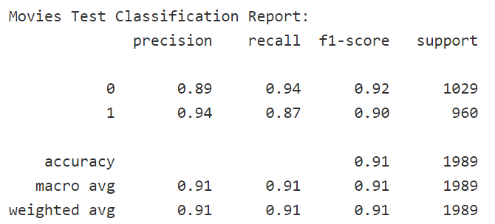

The model performed slightly better at predicting whether someone would enroll than its performance in predicting who wouldn’t sign up for the streaming service

Visualization of ROC curve
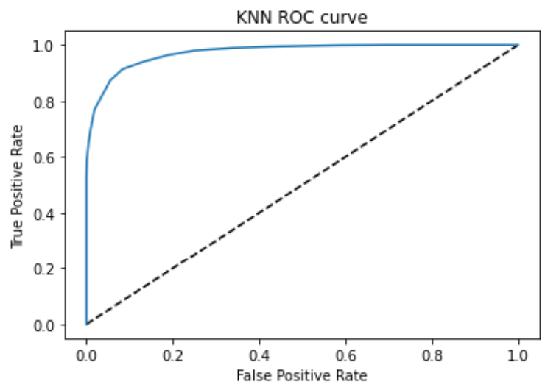

Calculating the ROC AUC score found to be .9739

An AUC score of .974 is a great score and indicates that our majority threshold of .5 is a good fit for the model. This could be a sign that our KNN n-neighbors is a bit expansive and could be reduced from 39 to a smaller number and we could play around with the majority threshold a little more to build a faster model, but for the job it needed to do our model is perfect.

Visualization of True Positive Rate and the False Positive Rate by thresholds

False Positive rate in Orange and True Positive Rate in Blue

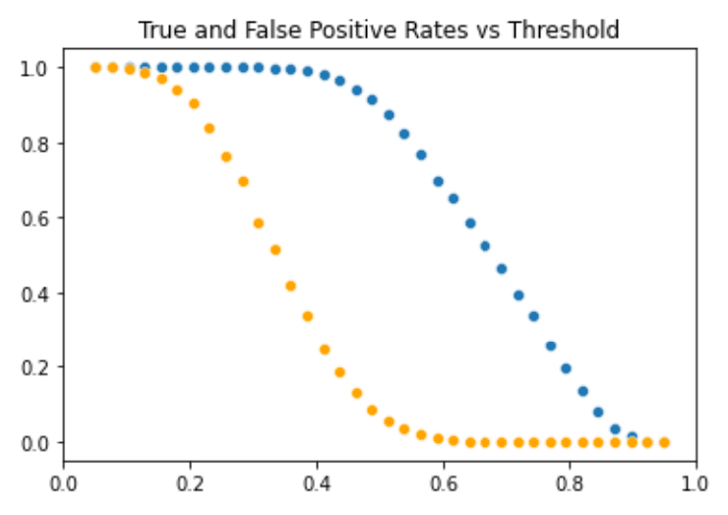

This is another visual that helps us have a comfortable grasp of how our thresholds affect the accuracy of our model. We see a steep drop in the rate of both lines around the .5 threshold mark indicating an optimal threshold within .485-.53.

Creating table for additional visual to see how threshold optimization could work

First, I created a dataframe of the tpr ,fpr and the thresholds. Then I calculated the g-mean as the square root of sensitivity * specificity which can be calculated as sqrt( tpr * (1-fpr)) and this also gave us a range of values for the optimal threshold. If you look at the two threshold values with the greatest g-mean, you’ll notice that .50 which is the default threshold would lie in the middle of the two threshold values indicating we already have an optimal threshold.

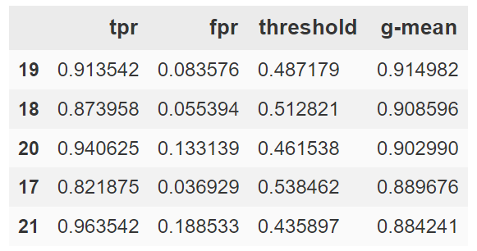

Calculating Sensitivity, Accuracy, Specificity and Precision using the tpr fpr values

tp: True Positive

fp: False Positive

Precision = tp/(tp+fp)

Accuracy = (tn + tp)/(tp+fn+fp+tn)
Sensitivity = (tp)/(fn+tp)
Specificity = tn/(fp+tn)

Code for analysis

#Calculating the Area under curve value and visualizing the ROC curve
from sklearn.metrics import roc_curve
from sklearn.metrics import roc_auc_score
y_pred_prob = classifier.predict_proba(X_test)[:,1]
fpr, tpr, thresholds = roc_curve(y_test,y_pred_prob)
plt.plot([0,1],[0,1],'k--')
plt.plot(fpr,tpr,label = 'KNN')
plt.xlabel('False Positive Rate')
plt.ylabel('True Positive Rate')
plt.title('KNN ROC curve')
plt.show()
print(roc_auc_score(y_test,y_pred_prob))
#Visualizing the tpr and fpr on the threshold range
sns.scatterplot(y = tpr, x = thresholds)
sns.scatterplot(x = thresholds, y = fpr, color = 'orange')
plt.title('True and False Positive Rates vs Threshold')
plt.show()
tn = 0
tp = 0
fp = 0
fn = 0
# Applying predicted values from prob streaming for threshold analysis
for lab,row in test.iterrows():
if test.loc[lab,'PredStreamingMovies'] == 0:
if test.loc[lab,'StreamingMovies'] == 0:
tn += 1
else:
fn +=1
elif test.loc[lab,'PredStreamingMovies'] == 1:
if test.loc[lab,'StreamingMovies'] == 1:
tp += 1
else:
fp +=1

#Calculating Performance metrics with True Positives, False Positives,
# True Negatives and False Negatives
accuracy = (tn + tp)/(tp+fn+fp+tn)
accuracy
sensitivity = (tp)/(fn+tp)
sensitivity
specificity = tn/(fp+tn)
# Printing Metrics
print(f'precision:{tp/(tp+fp)}')
print(f'accuracy:{accuracy}')
print(f'sensitivity:{sensitivity}')
print(f'specificity:{specificity}')
#Creating dataframe to view the tpr, fpr and the g-means
df = {
'tpr' : tpr,
'fpr' : fpr,
'threshold' : thresholds
}
df = pd.DataFrame(df)
df['g-mean'] = np.sqrt((df['tpr'])*(1 - df['fpr']))
df.sort_values(by = ['g-mean'],ascending = False).head()

Part V Data Summary

- Area Under Curve

Our AUC score is .974

This score is extremely high and shows that the model is successful in assigning whether a customer is signed up for the streaming movies service with an optimal threshold. Credit to the Cross-validation process because it helped us find optimal parameters for area under curve which helped us avoid the search for a more optimal threshold.

- Classification Report

Found a precision of .936. When the model assigns a customer as being a customer those streams movies the model is correct 93.6% of the time.

The model’s ability to predict whether someone would stream movies was a sensitivity of .874, not the best compared to our other metrics.

The accuracy of the model was .911, when the model classifies a customer as one that streams movies or not it is correct 91.1% of the time.

The model excelled at determining whether someone would not stream movies with a specificity of .945.

- Limitation of Data Analysis

One limitation of the model is that the model assumes values close to one another are similar to each other, while our model performed well who’s to say it will in the future? We don’t know if these patterns will continue, and we definitely can’t use it in confidence to offer streaming services to a brand-new customer given the nature of the training and test dataset being on established customers at the company. This model should be used with caution and should be revamped at least every month or prior to starting any projects that incorporate this model to refresh training data and monitor its performance over time.

- Recommended Course of Action

While this model may not be powerful in predicting whether a new customer will sign up for the service, this model can be a great tool for marketing discounted options to current customers to build the consumer base that streams movies.

The power of this model in tandem with a model that predicts likelihood to churn could be used to assess how likely a customer is to churn with an increase to their monthly contract. If a customer is above 50% predicted probability to stream movies and don’t own the streaming movies service, they can be viable a target for a discount option because they are likely to take it, but it would largely depend on how much they pay a month for their current services. We do not want to force customers away with features they cannot afford. Tenure is correlated with churn as customer loyalty grows over time, so we can expect tenured customers not enrolled in streaming movies to be a viable target especially if this model has found them to be likely to be streaming movies.

